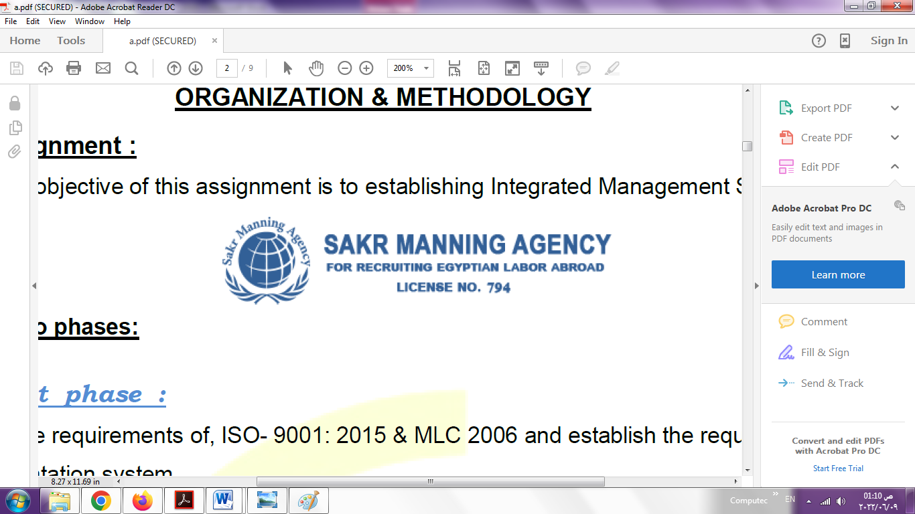 | SAKR MANNING AGENCY  FOR RECRUITING EGYPTIAN LABOR ABROAD | Issue Date | 15.05.2022
 |  | Revision Date | 19.07.2022
 | Crewing Management Manual  Seafarer Employment Application | Revision | 1.1
 |  | Page | 3

Application For Position as | Oiler
Register Code. | ER-3.002
Other Position (If Any) | Oiler /AB
Register Date | 19/9/2022
Last up Date Data

1. PERSONAL DETAILS
Full Name |  | Ahmed Mohamed Abd ELATIF AHMED ISMAIL
Date Of Birth |  | 22/6/1999 |  |  |  |  |  |  | Place Of Birth |  |  |  |  |  |  |  | dirb najm alsharqiih
Nationality |  | Egyptian |  |  |  |  |  |  | Marital Status |  |  |  |  |  |  |  | Single ☐✔️ |  |  |  |  |  |  |  | Married ☐
Height (Cm) |  | 173 |  |  |  |  |  |  | Overall Size |  |  |  |  |  |  |  | XL |  |  |  |  | Shirt Size
Weight (Kg) |  | 74 |  |  |  |  |  |  | Trouser Size |  |  |  |  |  |  |  | 34 |  |  |  |  | Shoes Size |  |  |  |  |  | 43
2. EDUCATION
College / School |  | maehad munsha'at bihrayh
Marline Test |  | Issued Date |  |  |  |  | Result % |  |  |  | Issued By (Authority) |  |  |  |  |  |  |  |  |  | Issued At
 |  | 2017 |  |  |  |  | 90/ |  |  |  | college technology |  |  |  |  |  |  |  |  |  | 2019
English Language |  | Fluent ☐ |  |  |  |  |  | Good ☐✔️ |  |  |  |  | Average ☐ |  |  |  |  |  |  |  | Poor ☐
……… Language  ( ) |  | Fluent ☐ |  |  |  |  |  | Good✔️☐ |  |  |  |  | Average ☐ |  |  |  |  |  |  |  | Poor ☐
3. CONTACT DETAILS
Home Address / City |  |  | aljawashinuh dirb najm alsharqiih
E-Mail |  |  | Ahmed534Hamada@gmill.com |  |  |  |  |  |  | Mobile / Tel |  |  |  |  |  | 01093188493

4. TRAVEL DOCUMENTS
Type |  | Document No. |  |  |  | ISS. Date |  |  | Exp. Date |  |  |  |  | ISS. By (Authority) |  |  |  |  |  |  |  |  |  | Place of Issue
Passport |  | A27452248 |  |  |  | 10/2020 |  |  | 10/2027 |  |  |  |  | Egyptian Authority |  |  |  |  |  |  |  |  |  | Zagazig passports
Seaman Book |  | S00003079 |  |  |  | 9/2019 |  |  | 8/2024 |  |  |  |  | EAMS |  |  |  |  |  |  |  |  |  | Alex.
Other Seaman Book

5. PROFESSIONAL QUALIFICATION / CERTIFICATE OF COMPETENCY
Certificate Name |  |  |  |  | Number | Issue Date |  |  |  |  |  | Expiry Date |  |  |  |  |  | Issued By |  |  |  |  |  |  |  |  | Issued At
COC |  |  |  |  |  |  |  |  |  |  |  |  |  |  |  |  |  | EAMS |  |  |  |  |  |  |  |  | Alex.
GOC |  |  |  |  |  |  |  |  |  |  |  |  |  |  |  |  |  | NTRA |  |  |  |  |  |  |  |  | Cairo
D.P. INDUCTION
D.P. ADVANCED
D.P. OPERATOR (UNLIMITED)
6. NEXT OF KIN
Full Name | Mohamed Abd ELATIF AHMED |  |  |  |  |  |  |  |  |  |  |  |  |  | Relationship |  |  |  |  | My Father
Address | aljawashinuh dirb najm alsharqiih
Tel. No. | 01288589284 |  |  |  |  |  |  |  |  | Mobile
7. HEALTH CERTIFICATES & VACCINATIONS
Flag State |  |  |  | Number |  |  | Issue Date |  |  |  |  | Expiry Date |  |  |  |  |  |  | Issued By |  |  |  |  |  |  | Issued At
International Medical |  |  |  | 08484 |  |  | 2/2022 |  |  |  |  | 2/2024 |  |  |  |  |  |  | EAMS |  |  |  |  |  |  | Alex.
Yellow Fever |  |  |  | 2/2022 |  |  | free |  |  |  |  |  |  |  |  |  |  |  | Ministry of Health |  |  |  |  |  |  | aladarah aleamah lilhajar alsihiyi
Cholera |  |  |  |  |  |  |  |  |  |  |  |  |  |  |  |  |  |  | Ministry of Health
Covid-19 |  |  |  | Vaccination Name |  |  | First Dose |  |  |  |  | Second Dose |  |  |  |  |  |  | (Other Does or Remarks)
 |  |  |  | Astrazeneca Short lnteral |  |  | 6/2/2022 |  |  |  |  | 7/3/2022

8. MARINE COURSES
Course Name | Number | Issue Date | Expiry Date | Issued By / At
Personal Survival Techniques | NR17501 | 1/2020 | 1/2025 | Naval Postgraduate Institute
Proficiency In Personal Survival Techniques | NR17395 | 1/2020 | 1/2025 | Naval Postgraduate Institute
Fire Prevention and Fire Fighting | NR17500 | 1/2020 | 1/2025 | Naval Postgraduate Institute
Advanced Fire Prevention and Fire Fighting
Elementary First Aid | NR17499 | 1/2020 | 1/2025 | Naval Postgraduate Institute
Medical Care Studies
Personal Safety and Social Responsibilities | NR17356 | 1/2020 | 1/2025 | Naval Postgraduate Institute
Proficiency Of Security Awareness Training Seafarers
Proficiency as a ship Security officer ( PSSO )
Proficiency In Survival Craft & Rescue Boats | 02911 | 4/2022 | 8/2024 | The Egyptian Authority for the Safety of Maritime Navigation
G.M.D.S.S
Communications
Advanced Communications
ECDIS Advanced Simulator (Management Level)
ECDIS Simulator (Operation Level)
Prevention and Combating of Marine Pollution
Radar & ARPA Simulator and Search &rescue
ARPA Simulator and Search
Marine Radar and automatic Radar Plotting
Bridge resource Management (B.R.M)
Engine resource Management (E.R.M)
Navigational Watch keeping
Proficiency for Rating forming part of Navigational watch (II/4) |  |  |  | EAMS / Alex.
High voltage training – operation of ship (1000 Volt and More)
Passenger Safety Cargo Safety and Hull integrity
Crowd Management Training
Crisis Management and Human Behavior Training
Safety training for Personal Prov. Direct Passengers
Practical Ability to Prepare Meals and (MLC 2006)
Personal Hygiene and Envir. Protection (MLC 2006)
Safety and Health in the Provision Meals (MLC 2006)
Food Storage and inventory Control (MLC 2006)
Ships Cook Certificate (MLC 2006) |  |  |  | EAMS / Alex.
Abel Seafarer Deck
Proficiency for Abel Seafarer Deck ( II/5 ) |  |  |  | EAMS / Alex.
Engineering Watch keeping |  |  |  | EAMS / Alex.
Proficiency for Rating forming part of a watch in engine room | 00768 | 4/2022 | Free | The Egyptian Authority for the Safety of Maritime Navigation
Abel Seafarer Engine
Proficiency for Abel Seafarer Engine ( III/5 ) |  |  |  | EAMS / Alex.
Electro Technical Rating
Proficiency for Electro Technical rating ( III/7 ) |  |  |  | EAMS / Alex.

COMPLETE SEA – SERVICE DETAILS

Name: | Ahmed Mohamed Abd ELATIF AHMED ISMAIL |  |  |  |  |  |  | Rank: |  |  | Oiler |  |  |  |  | Register Code:
Company Name |  |  | Rank |  | Vessel Name |  |  |  | Signed On |  |  | Signed Off |  |  |  | Period |  |  | Vessel Type |  | D.W.T. |  |  |  |  | Engine Type |  |  | BH | KW
DelmarMarilne Transport Company |  |  | Oiler |  | OTS YEOMAN  PANAMA |  |  |  | 11.9.2021 |  |  | 7/4/2022 |  |  |  | 7 Month |  |  | sablay 'abhath bitrulih |  | 1300 |  |  |  |  | Engine type  HP & Aux. eng .  GM EMD 24/30  2 Stroke 2×2150 HP  DETROIT 1800 RPM  HP 725, RPM 1800  2 Stroke ( U S A ) |  |  | 725HB | 2797
SPECIALISED EXPERIENCE
Name |  |  |  |  |  |  |  |  |  | Type |  |  |  | From |  |  | To |  |  |  |  | Comments
The Port Said Engineering Works Company, affiliated to the Suez Canal Authority |  |  |  |  |  |  |  |  |  |  |  |  |  | 2018 |  |  | 2019
I declare that the information I have given is, to the best of my knowledge, true and complete. I also declare that the documents submitted are genuine, given and sign by persons whose names appear on them.
 |  |  |  |  |  |  |  |  |  |  |  |  | 13/9/2022 |  |  |  |  |  |  |  |  |  | Ahmed Mohamed Abd ELATIF AHMED ISMAIL
 |  |  |  |  |  |  |  |  |  |  |  |  |  |  | DATE |  |  |  |  |  |  |  |  |  | SIGNATURE

